**FOOD SHARER MOBILE APPLICATION**

**IT7513- SOCIALLY RELEVANT PROJECT**

**A REPORT**

***Submitted by***

**KANNAN BS– 2018506047**

**KAMALNATH KN - 2018506044**

**SUBHA K- 2018506127**

**RACHURI PAVAN KUMAR-2018506088**



**DEPARTMENT OF INFORMATION TECHNOLOGY**

**MADRAS INSTITUTE OF TECHNOLOGY CAMPUS**

**ANNA UNIVERSITY: CHENNAI 600 044**

**NOVEMBER, 2020­**

**DEPARTMENT OF INFORMATION TECHNOLOGY**

**ANNA UNIVERSITY, CHENNAI 600044**

**BONAFIDE CERTIFICATE**

Certified that socially relevant project Report titled “**FOOD SHARER MOBILE**

**APPLICATION**” is the bonafide work of **KANNAN BS (2018506047),**

**KAMALNATH KN (2018506044),SUBHA K (2018506127), RACHURI PAVAN**

**KUMAR(2018506088)** whocarried out the project work under my supervision.

Certified further that to the best ofmy knowledge the work reported herein does not

form part or full of any other thesisor dissertation on the basis of which a degree or

award was conferred on an earlieroccasion on this to any other candidate.

**SIGNATURE**

**Dr. P. KOLA SUJATHA**

**SUPERVISOR**

Department of Information Technology

MIT Campus, Anna University

Chennai-600 004

**ACKNOWLEDGEMENT**

The satisfaction that accompanies the successful completion of our task would be

incomplete without mentioning the names of people who made it possible, whose

constant guidance and encouragement crowns all efforts with success. We

express our gratitude and sincere thanks to our respected Dean,

**DR.T.THIYAGARAJAN**, Anna University, MIT Campus for providing the

excellent computing facilities to do the project. Our heartfelt thanks to

**DR.DHANANJAY KUMAR**, Head, Department of Information Technology,

Madras Institute of Technology Campus, Anna University, for the prompt and

limitless help in providing the excellent computing facilities to do the project. We

express our profound sense of gratitude to our project panel Member

**DR.P.KOLASUJATHA**, Department of Information Technology for their

invaluable support, guidance and encouragement for the successful completion

of this project.

**TABLE OF CONTENTS**

**CHAPTER TITLE PAGE**

**ABSTRACT 5**

**LIST OF FIGURES 6**

**LIST OF ABBREVIATION 7**

**1**. **INTRODUCTION** **8**

1.1. OVERVIEW 8

1.2. EXISTING APPROACHES 8

1.3.MOTIVATION 9

1.4. PROBLEM STATEMENT 9

**2.** **LITERATURE SURVEY 10**

**3. PROPOSED WORK 12**

3.1. MODULES 12

3.2 ARCHITECTURE DIAGRAM 14

**4. IMPLEMENTATION AND ANALYSIS 15**

4.1. PROJECT DESCRIPTION 15

4.2. PERFORMANCE 16

4.3. SCREENSHOTS 17

**5. CONCLUSION AND FUTURE WORK 24**

**REFERENCES 25**

**ABSTRACT**

Food is one of the most vital and basic thing for a human survival. We are living in a

world where there are lot of inequalities.For example there are families who has so

much money that they can feed many of their generations on the other hand there are

families who are not even able to make the ends meet for their basic survival. This

problem is not specific to developing countries but developed countries are too affected

by this problem. From the land to the table, foods gets wasted in many parts of its

processing cycle. Hunger deaths are the worst thing that could happen to humanity. This

types of deaths occur not due to the failure of the man but due to the failure of the entire

society in which we live. We are living in a society where everyone is busy with their

own work but when it comes to hunger no one can compromise the fact that food is the

basic necessity for life. So we are much obliged to provide a solution for this societal

evil of food waste by developing an mobile application using which any people who is

having excess of food can share it to the needy at free of cost. This mobile app will

connect the volunteers with the distributor who will process the excess food and

distribute it, so the needy is benefited. The people will be able to post the excess food

details in our app and it will be displayed to all users and the distributors will come

forward to distribute it to the beneficiaries. We are happy to devote our work to one of

the most important and essential cause which was not given enough attention

before.This project act as a bridge between the food donors and acceptors who need the

help from our society.

**LIST OF FIGURES**

**FIGURE NO FIGURE TITLE PAGENO**

**3.2 ARCHITECTURE DIAGRAM 14**

**4.3.1 HOME PAGE 17**

**4.3.2 LOGIN PAGE 18**

**4.3.3 SIGNIN FROM GMAIL 19**

**4.3.4 DASHBOARD 20**

**4.3.5 UPLOAD PAGE AND POSTING FOOD DETAILS 21**

**4.3.6 VIDEOS FOR FOOD MANAGEMENT 22**

**4.3.7 POSTED PAGE 23**

**LIST OF ABBREVIATION**

1. **Non-Governmental Organization** (**NGO**)
2. **The Food and Agriculture Organization of the United Nations ( FAO )**
3. **Graphical User Interface** (GUI)
4. **Extensible Markup Language(XML)**
5. **DataBase(DB)**

**CHAPTER 1**

**INTRODUCTION**

**1.1 OVERVIEW**

Food waste is huge crisis arising in today’s world. Recently, the issue of surplus food

management has attracted much attention from academics and practitioners, since it is

believed to have a huge possibility to reduce food insecurity, i.e. the condition when the

food intake of some household members is reduced and normal eating patterns are

disrupted at times due to limited resources .Food insecurity and food losses together

generate a paradoxical reality; a total of 842 million people worldwide were estimated

to be suffering from regularly not getting enough food, while approximately 1.3 billion

tons per year food is wasted globally. Food insecurity is a relevant issue even in high-

income countries. Today, in Europe, nearly 43.6 million people are estimated to be food

insecure. At the same time, European countries are reported to generate 179 kg per

capita of food waste every year. In other words, 89 million tons per year food is wasted

in Europe, approximately 58% of what is produced by firms in manufacturing,

wholesale, retail and food service stages of the food supply chain. Besides the economic

loss for the firms producing food waste, social and environmental losses are also clear

especially when the food is edible but for various reasons is not sold to or consumed to

the intended customer and eventually becomes waste.

**1.2 EXISTING SYSTEM:**

Presently people who wish to donate items need to personally visit the organizations

and donate foods or other items. Otherwise, they have to search for some websites to

donate surplus food. In general, the large manufacturers, wholesalers, and organized

community provide food items to food banks or waste tons of foods daily. They have

to search for some organization that needs food. This process involves a lot of time to

contact the organization to check the requirement. If they do not need the food, then

the person has to contact another organization. This makes the donor tired and

exhausted.

**1.3 MOTIVATION:**

Most people don't realize how much food they throw away every day — from uneaten

leftovers to spoiled produce . About 95 percent of the food we throw away ends up

in landfills or combustion facilities. In 2013, we disposed more than 35 million tons of

food waste . Many people wish to donate things to needy organizations. Also, many

organizations wish to ask for various things required by them such as clothes, food

grains, books, utensils, etc., but there is no source available through which they can

satisfy their requirements. Thereby, an Android application has been developed through

which people can donate items as per their capacity and the application also allows

organizations to put up their requests, i.e. items required by them, if any. The majority

of the population today uses smartphones with active internet connection, which is the

basic requirement for this product to function properly.

**1.4 PROBLEM STATEMENT:**

The product aims at satisfying the requirements of needy organizations through

donations over the net. The application shall ask the user/donor to register his/her

details into the system and then he/she can login and put up items to donate. Similarly,

organizations can register in the system and then put up their item requirements. Also,

a donor can view the list of items put up by seekers and can donate the same, if possible.

In the same way, seekers can view the list of items put up by donors and if required,

can claim the donated item by contacting the donor. The application is developed using

Android Studio and the languages used are core Java and XML. The main objectives of

the proposed application include reduction in wastage of food, making food, making

food, clothes, etc. available to orphanages, old age homes and other such organizations,

which will also inculcate values of sharing and sensitivity among people.

**CHAPTER 2**

**LITERATURE SURVEY**

The paper “**Food donation portal**” , which was published in 2015 summaries in brief

the evolution of food donation activities and offers a medium that connects donors with

NGOs. An idea for a food donation network is presented and impact on society through

this medium is mentioned. The disadvantage in this paper is that there is no GPS service

available. That means the system does not allow the organization or charity to find the

nearest donor available in the area and they have to manually find the donors.

The paper ‘ **Helping Hands**’ , published in 2016, a new internet-based application that

provides a platform for donating old stuff and leftover food to all needy

people/organizations. It provides information about the motivation to come up with

such an application, thereby describing the existing donation system and how the

proposed product works for the betterment of society .The disadvantage of this project

is that there is no dashboard available that is, at the end of the month the system don’ t

get all the records that how much is donated or received by the receiver.

The paper ‘**Beyond food sharing’**: Supporting food waste reduction With ICTs’[3],

published in 2016, guaranteeing food security is key in improving the quality of life of

citizens at all levels of society. The recent economic crisis has increased the number of

people living in conditions of food poverty, especially in developed regions. Despite a

growing awareness of the importance of reducing waste and managing food surplus, the

role of ICTs in this domain is still unclear and rarely documented. This paper describes

the use of ICT tools to recover food surplus at different stages of the supply chain and

also describes the way forward for an integrated set of ICT tools to reduce waste from

producers to households.

The paper “ **Food donations using a forecasting-simulation model’**, published in

2016, presents a methodology to estimate donations for non-profit hunger relief

organizations. These organizations are committed to alleviating hunger around the

world and depend mainly on the benevolence of donors to achieve their goals. However,

the quantity and frequency of donations they receive varies considerably over time

which presents a challenge in their fight to end hunger. A simulation model is developed

to determine the expected quantity of food donations received per month in a

multiwarehouse distribution network. The simulation model is based on a state-space

model for exponential smoothing. A numerical study is performed using data from a

non-profit hunger relief organization. The results show that good estimation accuracies

can be achieved with this approach. Furthermore, non-profit hunger relief organizations

can use the approach discussed in this paper to predict donations for proactive planning.

The Paper ‘ Smartphone Based Waste Food Supply Chain For Aurangabad City Using

GIS Location Based And Google Web Services’ [5], published in 2014, describes the

client-server GIS and Smartphone application for the hunger free city. At the client side

App provide facility to donate food to the charity for the help of hungry people. Donors

enter basic information like latitude and long quantity of waste food and type of waste

along with value and contact number. Charities can pick up that waste food and deliver

food to hungers. Completion of registration will placed onto server database where

charities can store the entries of donor in table format and shows the optimal path

between donor locations to nearest charity along with direction. So wastage food can

easily deliver to hungry people within a time.

**CHAPTER 3**

**PROPOSED WORK**

**3.1 MODULES**

**Module 1:**

**HOME PAGE PHASE:**

At first we started by developing a home page for User Registration. In this page we

have picture for our app and one simple button to enter into an app. While entering into

the app we will have two buttons which is login and register. If a user is new to this app,

first they have to register in this app by giving their details and after successful

registration only they can enter into the app. If a user is already a user to this app, then

they can directly enter into the app by just logging into this app. This two things are the

basic things to work in this app and these two buttons will lead us to all other pages in

this app. In this both login and register page, we will option for us to choose either we

are food provider or we are food needer.

**Module 2:**

**FORMS PHASE:**

In this phase we are concentrating in creating the various forms in different ways to

work into this app and also help us to move into other various pages. At first we will

create the form for new user, from where we get various information about the user such

as their Email, Password, Mobile no and so on. Next we will create the form for already

user from where they can log in by providing their registered mail id and their password.

Simultaneously while we are getting the information from the users we also store that

information in databases by providing the database connectivity to this app. Whatever

the actions performing in this app we are maintaining the database and the information

can be viewed at any time.

**Module 3:**

**FOOD PROVIDER PHASE:**

Nowadays, the No.of.deaths due to hungry is the most. In order to avoid that we are

developing this app to help whatever we can do for them. In this app the food providers

are those who have excess food in their houses, parties, hotels and so on. 12 The food

providers can register at any time whenever they can provide the food. Once registered

into this app they need not to register again and also they just need to login alone. The

food providers also have to fill the form like how much food they have, when they

prepared that food, how much distance that food is available and so on.

**Module 4:**

**FOOD NEEDER PHASE:**

In this phase, we will get the information about the food needer by providing the form.

The food needer persons are those really need the food which will fade away their

hungry. After log in into this app the food needers can view the post page which is

posted by the food provider. By viewing the information the food needers can directly

contact the food provider by making the calls. If the needer is very near from the

provider they can easily get the food by walk distance otherwise the food needer is far

away from the provider, the food provider will trace the food needer where they are by

using the Google maps to locate their location easily and the food providers will provide

the food to the needer.

**3.2ARCHITECTURE**

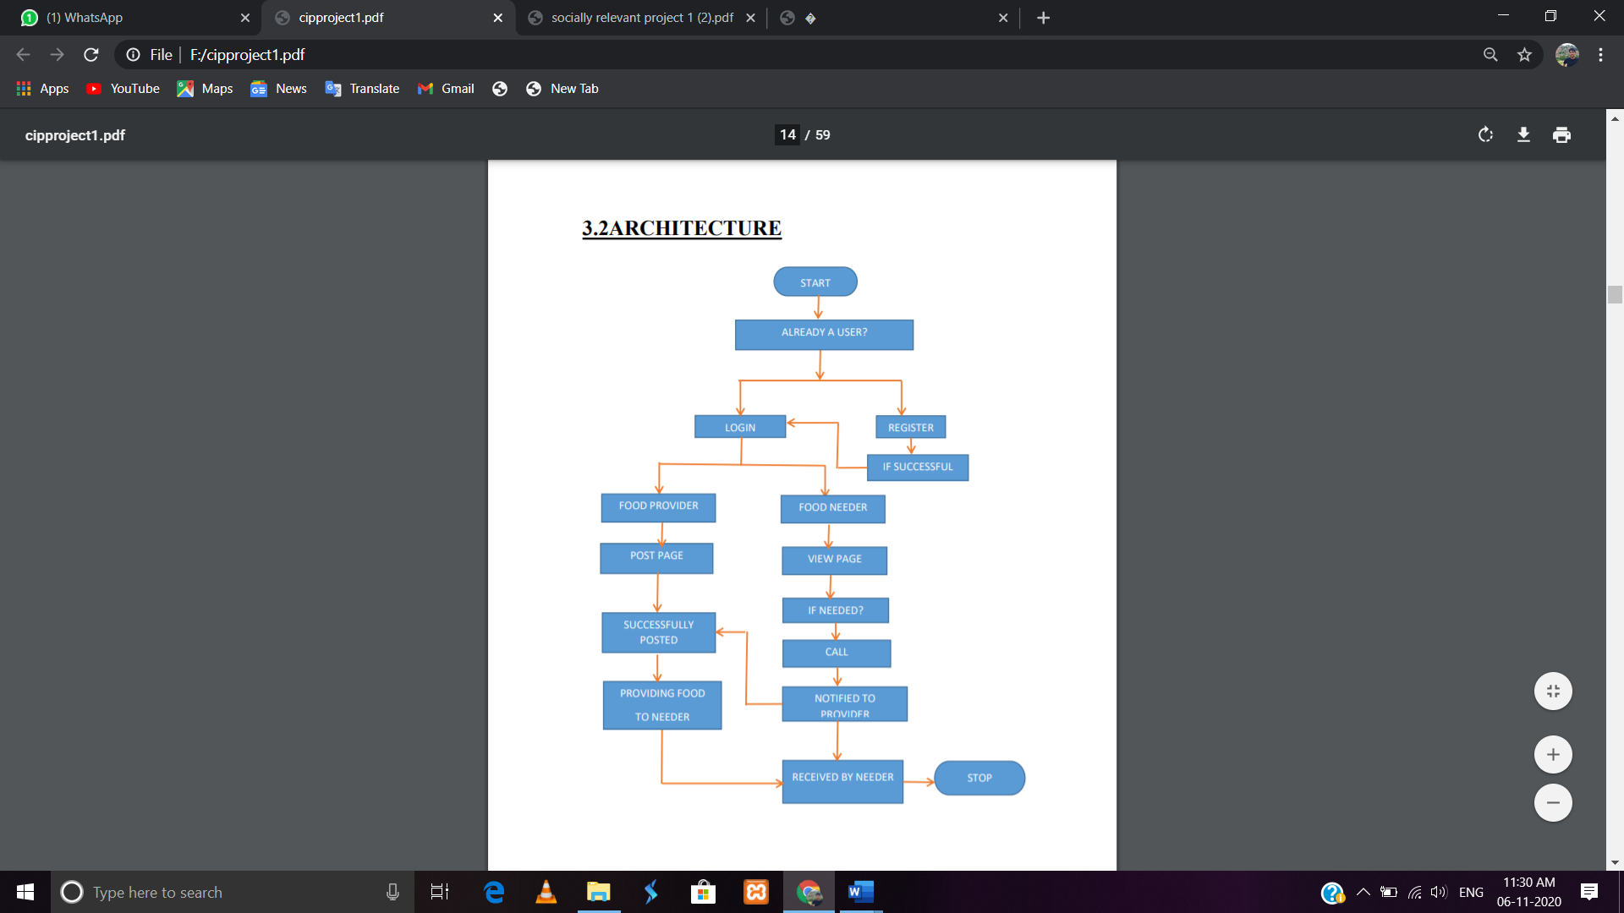

**CHAPTER 4**

**IMPLEMENTATION AND ANALYSIS**

**4.1 PROJECT DESCRIPTION:**

**OVERALL AIM:**

To develop a useful interface that helps in communication between the donors and the acceptors of food.

**SUB-TOPICS:**

**HOME PAGE:**

A page that allows the user to navigate through different parts of the project.

**SING IN/SIGN UP PAGE:**

A page that helps the users to choose between sign in and sign up.

**POST YOUR SURPLUS PAGE:**

This page allows the user to capture the picture of the food they are going to donate to

others.They have to submit atleast two pictures of the item,then only it allows to post

the food item.

**DONORS DETAILS PAGE:**

A page that displays information like donor name, phone number of donors, address,

veg or non-veg, quantity. These fields will be displayed only to acceptors who will

simultaneously uses the phone number in the table to contact and collect food from

donors.

**MANAGEMENT PAGE:**

A page that displays the youtube videos that decribe about how to prevent food

wastage,how we can conserve food etc.

**ACCEPTOR PAGE:**

When the acceptor selects the food they want then this page allows the acceptor to

make call to the donor.After making call they delete those item from the item list.

**4.2 PERFORMANCES:**

Our Graphical User Interface is designed in such a way that even a beginner can handle

the system with ease. We have rigorously tested the system for various inputs and our

system have responded to it with correct outputs and exception.We have divided the

system layout into various parts so that the user would find it easy to navigate across

various pages in the system. Since our system is a software oriented system it will not

get deteriorated over time so we need not care about maintenance. Our system enables

the acceptor of the food to make call to get the food from the donor.This app allows the

donor to capture the picture of the food to post and make available to the acceptor.

**4.3 SCREEN SHOTS:**

**HOME PAGE:**

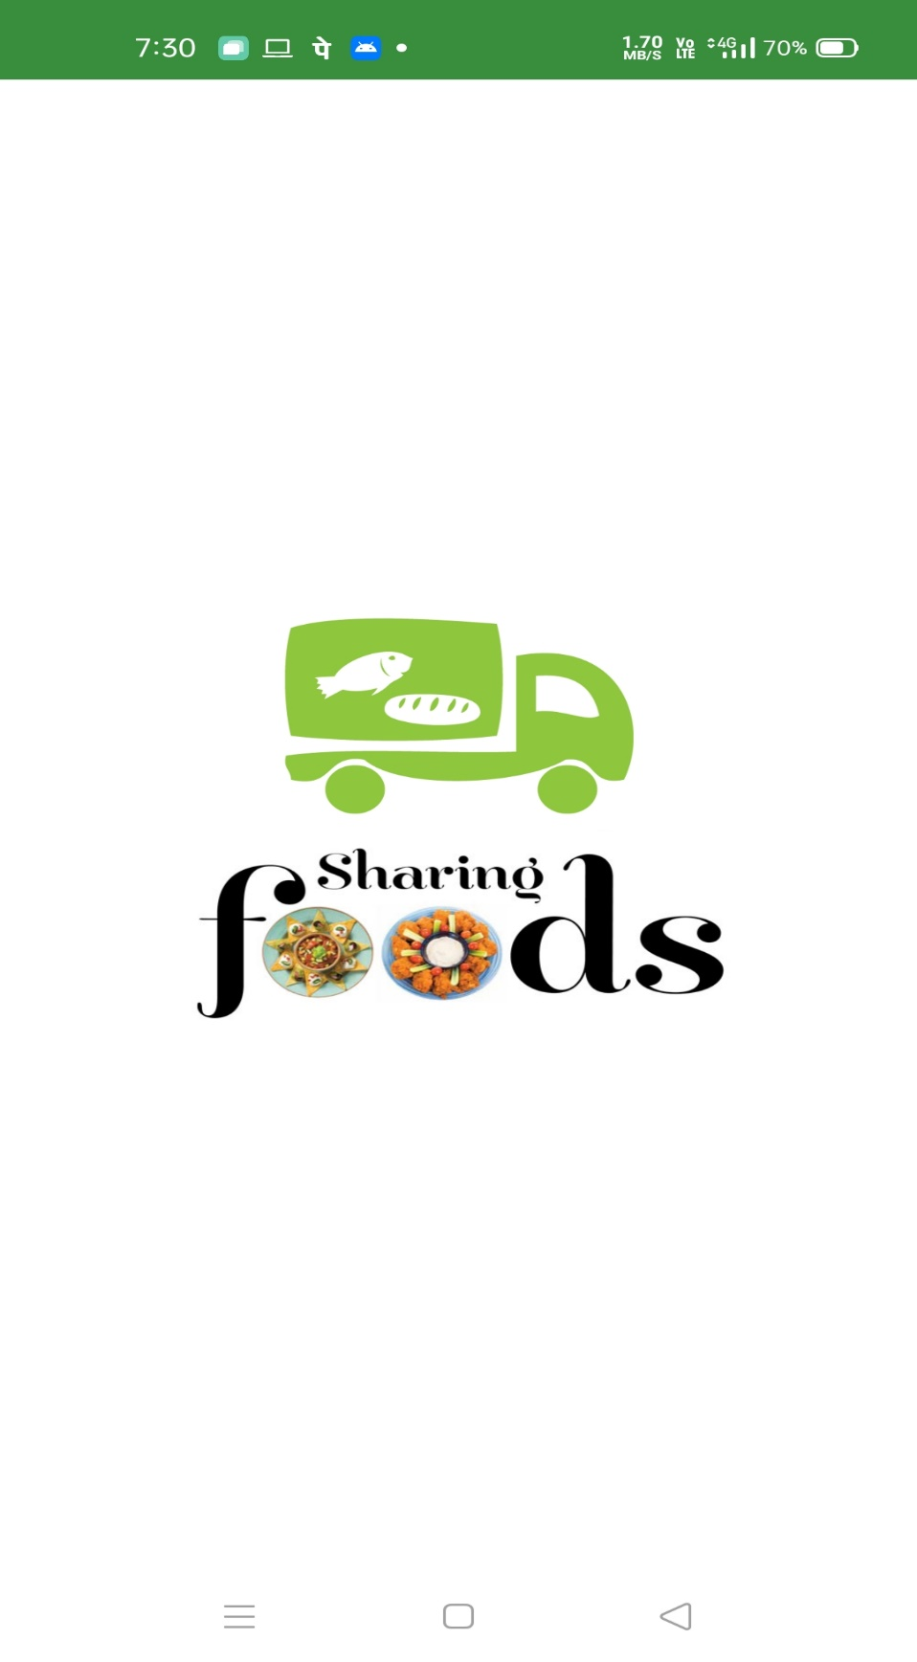

FIG 4.3.1 HOME PAGE

**LOGIN PAGE:**

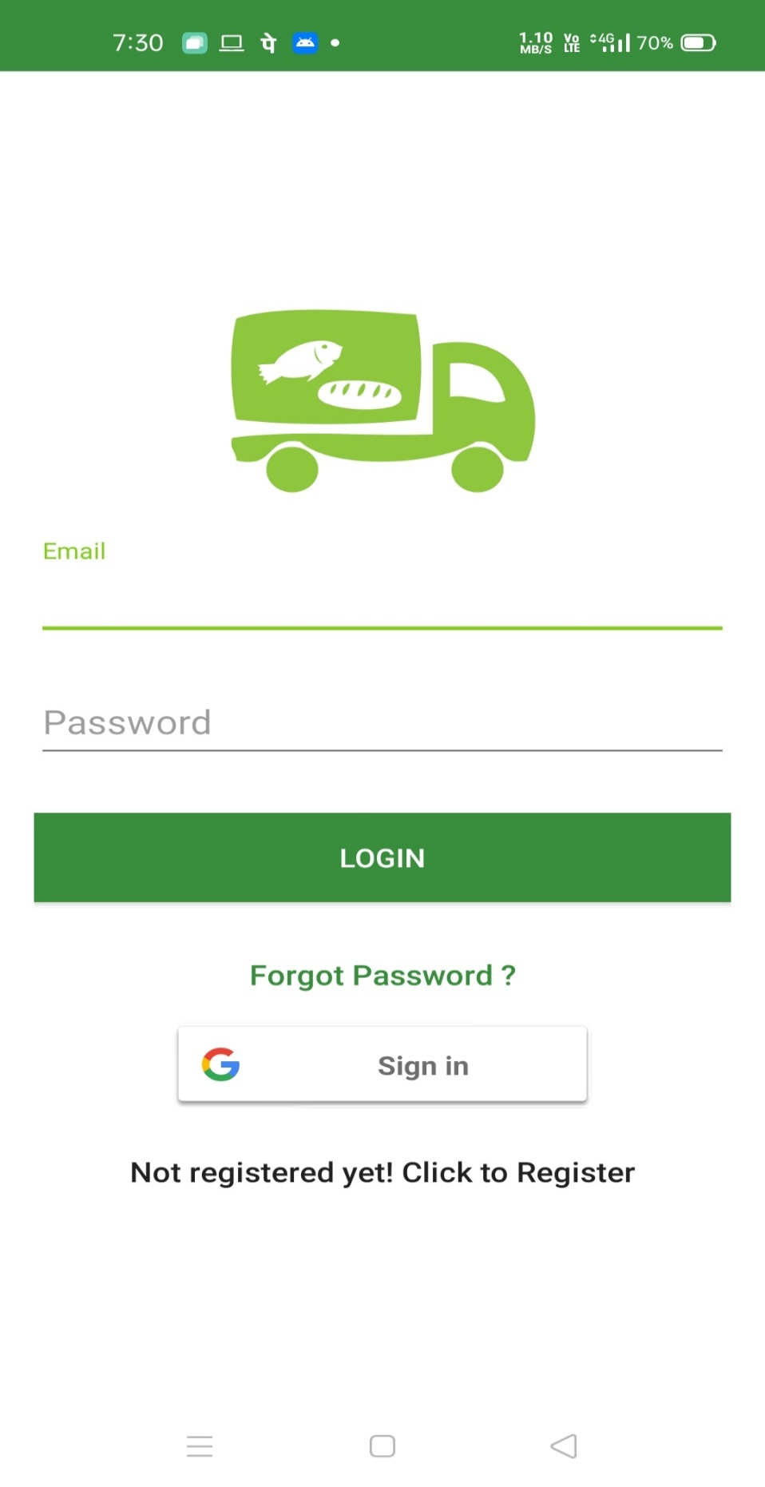

FIG 4.3.2 LOGIN PAGE

**SIGNIN FROM GMAIL:**

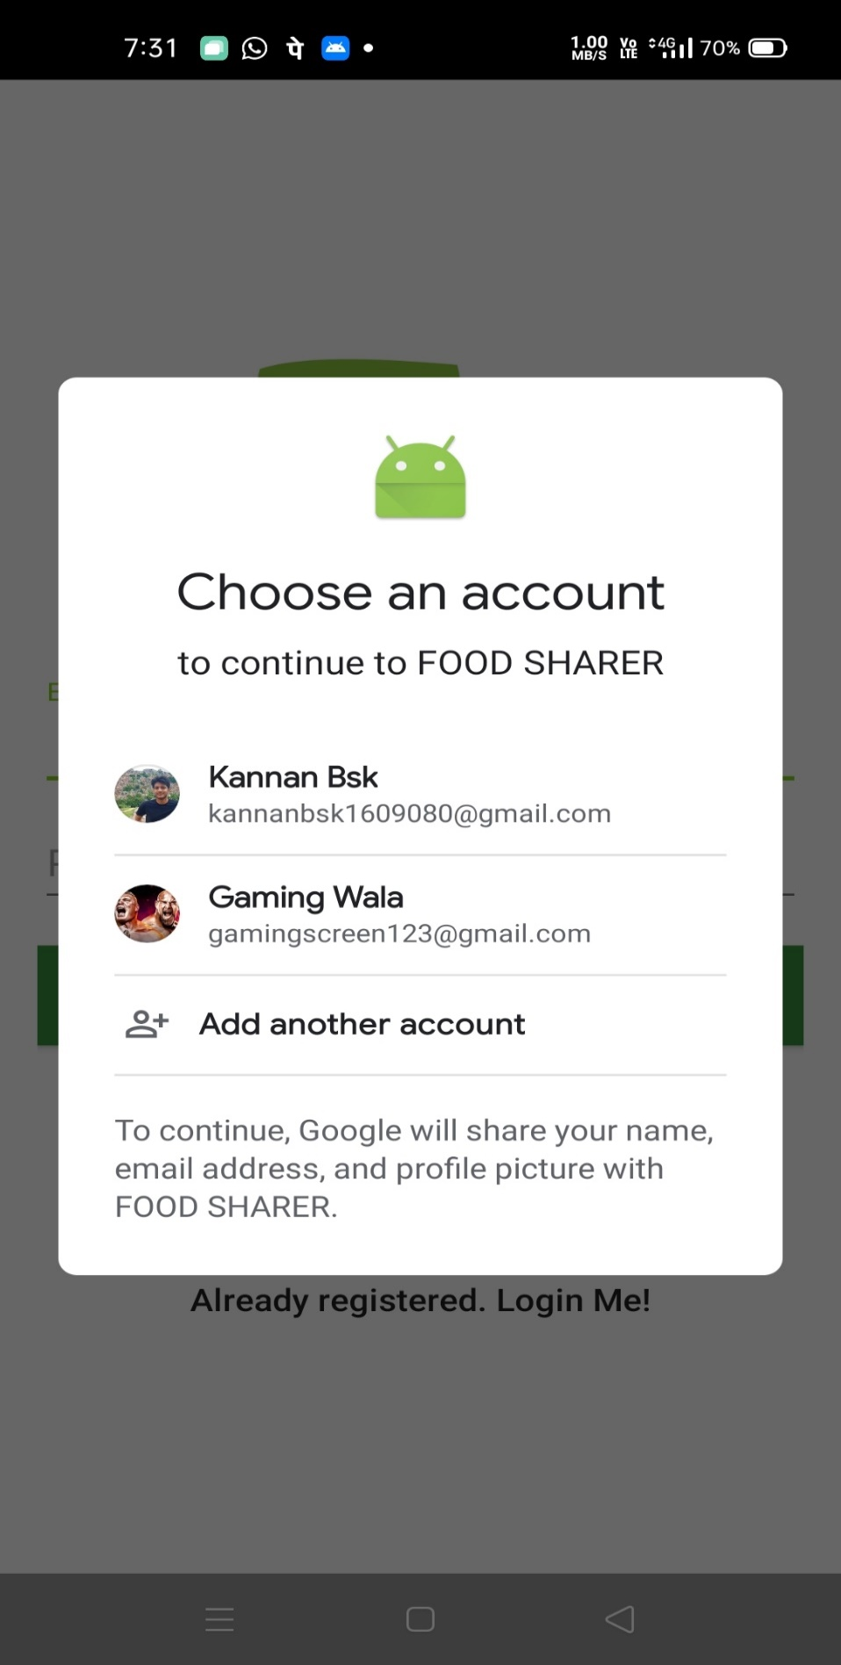

FIG 4.3.3 SIGNIN FROM GMAIL

**DASHBOARD:**

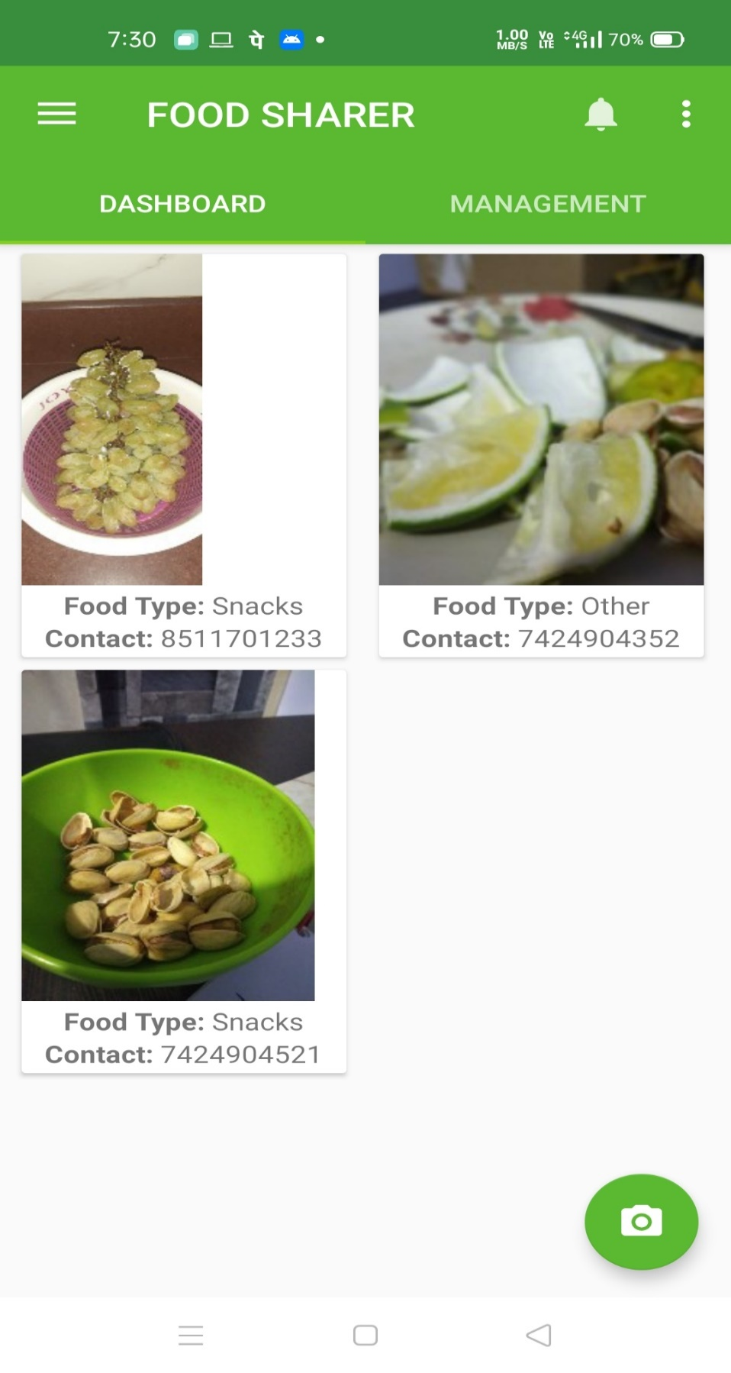

FIG 4.3.4 DASHBOARD

**UPLOAD PAGE AND POSTING FOOD DETAILS:**

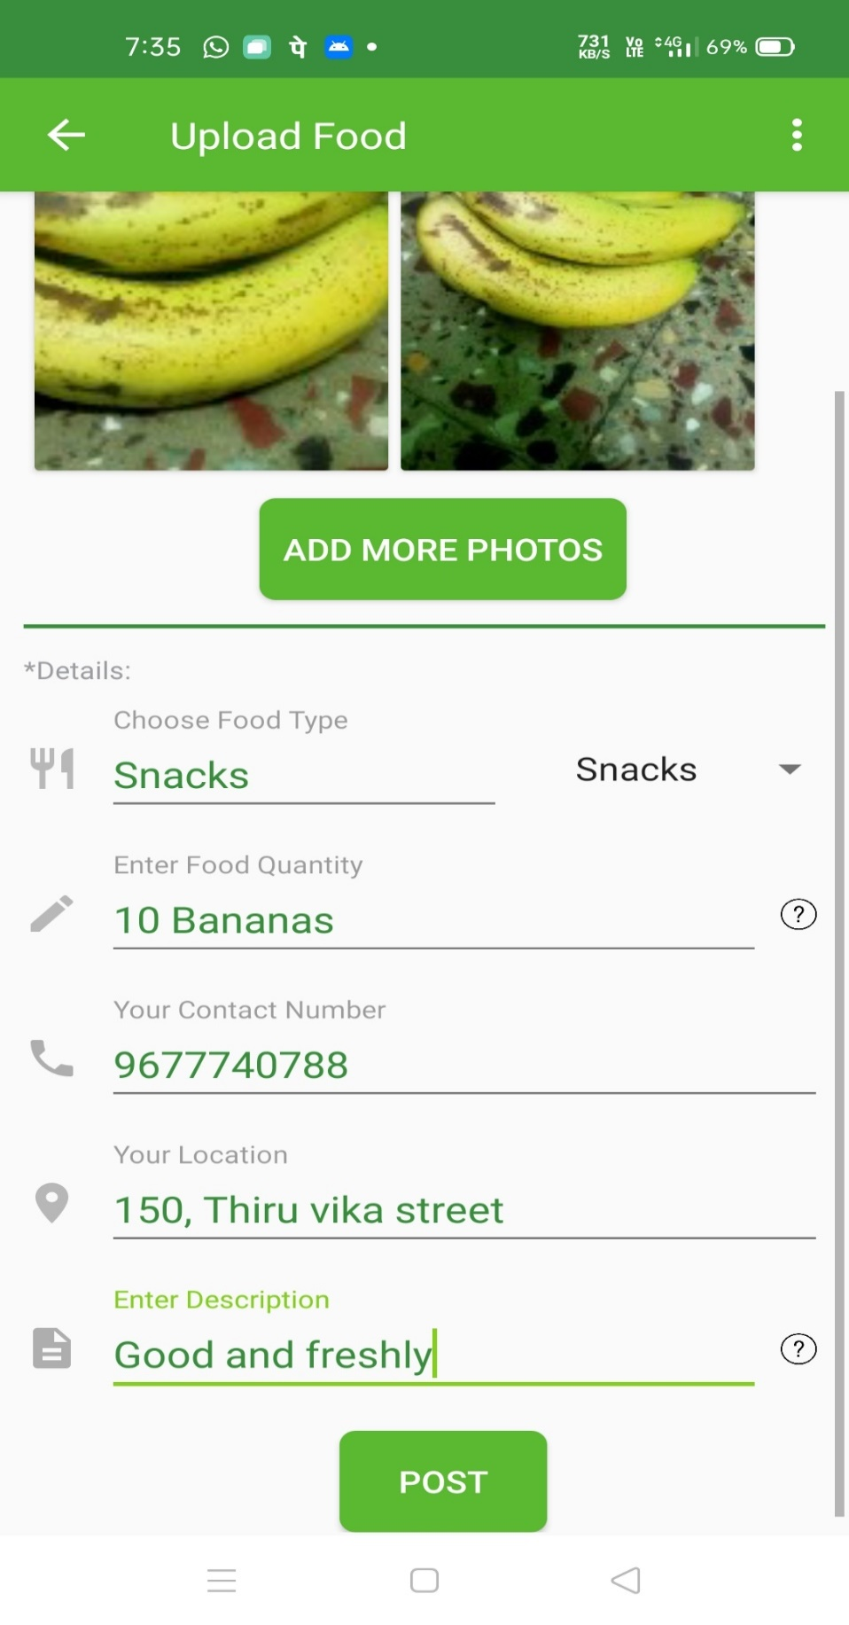

FIG 4.3.5 UPLOAD PAGE AND POSTING FOOD DETAILS

**VIDEOS FOR FOOD MANAGEMENT:**

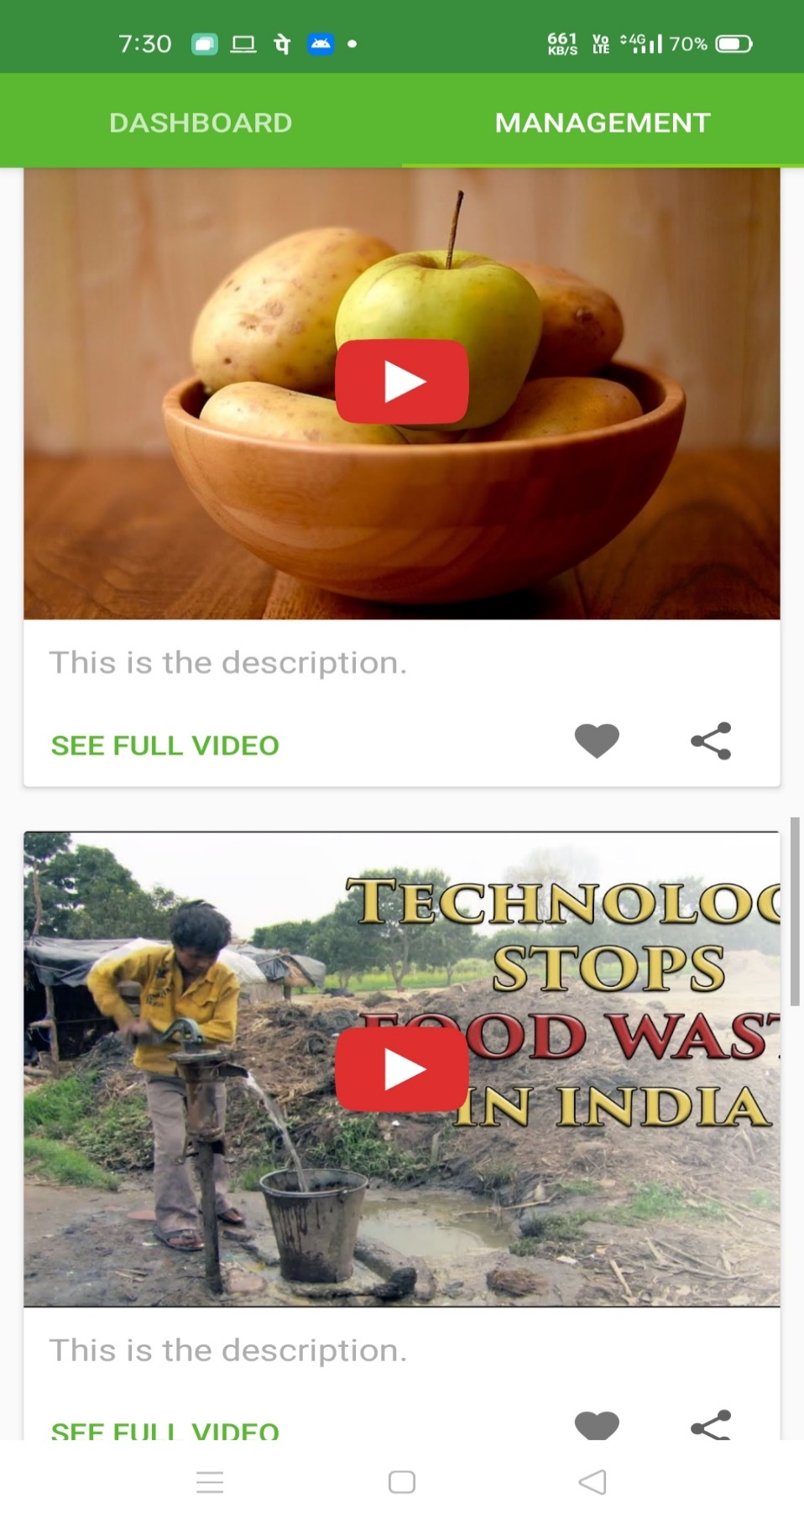

FIG 4.3.6 VIDEOS FOR FOOD MANAGEMENT

**POSTED PAGE:**

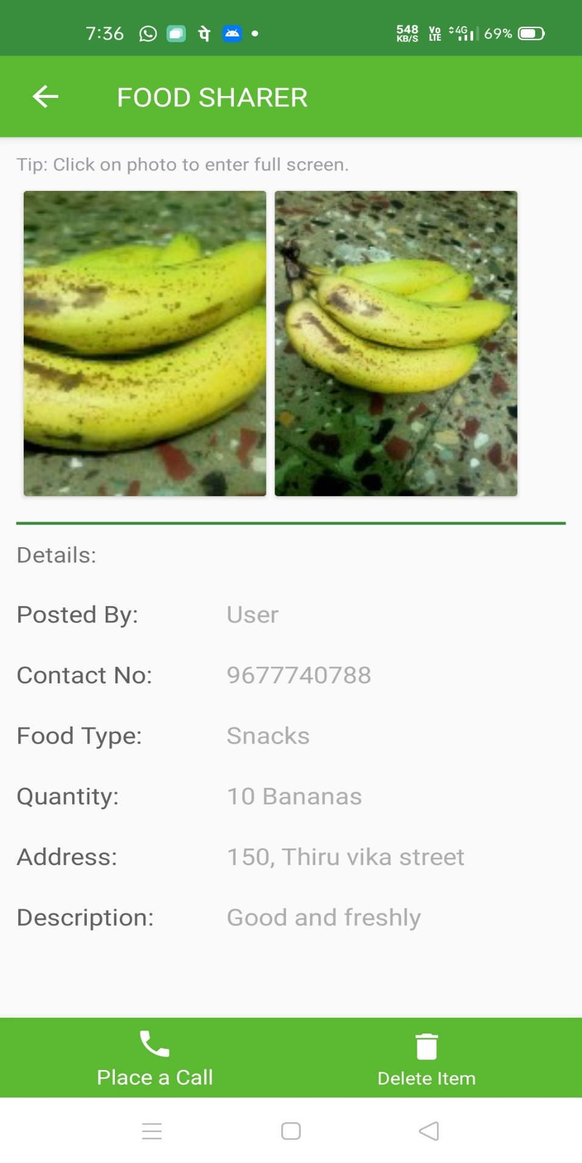

FIG 4.3.7 POSTED PAGE

**CHAPTER 5**

**CONCLUSION AND FUTURE WORK:**

We have tried our best to implement this project so that nobody sleeps with empty

stomach. We are proposing a future enhancement for this project. Those who are

interested in this project are free to develop this project in other platforms .The ultimate

aim of those who are future enhancing this project is to provide wide range services at

free of cost to the users. At last one thing to keep in mind about this project is that this

project is clearly service oriented and not money oriented. Let us all join hands for this

common cause.

**REFERENCES:**

1. Parfitt, J., Barthel, M., & Macnaughton, S. (2010). Food Waste within Food Supply

Chains: Quantification and Potential for Change to 2050. Philosophical Transactions of

the Royal Society, 2065-3081.

2. Ahumada, O., & Villalobos, J. (2009). Application of Planning Models in the Agri-

food Supply Chain: A Review. European Journal of Operational Research, 1-20.

3. Anik, L., Aknin, L., Norton, M., & Dunn, E. (2009). Feeling Good About Giving:

The Benefits (and Costs) of SelfInterested Charitable Behaviour. Harvard Business

School.

4. Beretta, C., Stoessel, F., Baier, U., & Hellweg, S. (2013). Quantifying Food Losses

and The Potential for Reduction. Waste Management , 764-773.

5. Darlington, R., & Rahimifard, S. (2006). A Responsive Demand Management

Framework for the Minimization of Waste in Convenience Food Manufacture.

International Journal of Computer Integrated Manufacturing, 1-22.

6. FAO. (2013). The State of Food Insecurity in the World. Rome, Italy: Food and

Agriculture Organization of the United Nations.

7. [www.rescuingleftovercuisine.org/](http://www.rescuingleftovercuisine.org/)

8. [www.annakshetra.org/](http://www.annakshetra.org/)

9. happylifewelfare.org/share-dabba-compaign.html

10.usf.vc/entrepreneur-info/india-meteoric-rise-smartphones/

11.www.epa.gov/recycle/reducing-wasted-food-home

12.http://www.youthkiawaaz.com/2014/09/innovative-trick-dabbawalas-m umbai-

feeding-many-hungry-children-city/&cat=General&ip=192.168.3.93 &user=-

&reason=Group

13.www.indiaactivities.com/caring-activities/donate-leftover-excess-

food/

14.http://developer.android.com/training/basics/firstapp/index.html

15.www.http://thecsrjournal.in/food-wastage-in-india-a-serious-concern/

16.https://www.google.co.in/?gfe_rd=cr&ei=FRXYVpC0DqnG8AeB_6HIDA

&gws_rd=ssl#q=android+tutorial+for+beginners+with+examples

17. Hello, Android: Introducing Google's Mobile Development Platform Book by Ed

Burnette

18. Bagherzadeh, Morvarid, Mitsuhiro Inamura, and Hyunchul Jeong. "Food waste

along the food chain." (2014).